SQL

DATA:
Every piece of information is called data. Data can be in form of characters, numbers.

DATABASE:
Organized collection of the data is called Database.

DBMS:
DBMS is the program which is designed to manage the database such as stores, retrieves and modifies data in the database on request.

SQL:
Structured Query Language is the language used to communicate with the database server to access, manipulate and control the data.

TABLE:
Relational database consists of one or more tables depending on the application. Table is the basic storage structure of the RDBMS. Tables will contain necessary data of the business with proper segregation.

ROW:
Row is also called as tuple. It will contain all the related data of particular record. Each row can be identified by primary key.

COLUMN:
Column will represent a kind of data. Example: Vendor Name

FIELD:
Field is the intersection of row and column.

SQL Statments
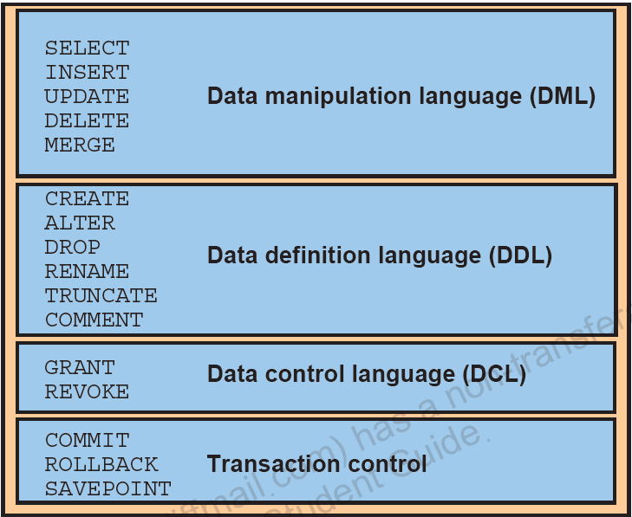

Datatypes:
- CHAR - alpha numeric, fixed length 255 characters// char name
- VARCHAR - alpha numeric, fixed size, 65535 characters, 2000 bytes
- VARCHAR2 – alphanumeric, variable length, 4000 bytes.
- NCHAR , NVARCHAR, NVARCHAR2 - Accepts national characters.
- NUMBER - accepts numeric data// 124
- LONG - character variable length, 2GB//
- DATE - date //15/06/2021
- CLOB – character large object 4GB
- BLOB – Binary Large object 4 GB

Data Definition Language:
- Create - Creating table structure with columns
Ex: Create table Players(Player_name varchar2(20),
Age number(3), Matches_played number(3), DOB Date)
Syntax: Create table table_name(column_name
datatype, …. column_name datatype)

- Alter - Modifying existing table
Ex: Alter table players Add Runs number(5)
Syntax: Alter table table_name

- Drop - Removing table from the database
Ex: Drop table players;
Syntax: Drop table table_name;

- Rename - Renaming the table name
Ex: Rename players to cricket;
Syntax: Rename old_table_name to new_table_name;

- Truncate - Deleting all rows from the table
Ex: Truncate table players;
Syntax: Truncate table table_name;

Data Manipulation Language:
- Select - Retrieves data from table
- Select * from table_name;
- Select column1,column2 from table_name;

- Insert - Add new row of data
Insert into TABLE_NAME (column1,column2)
values (column1_value,column2_value);

Eg: insert into sample(name, age) values('Revathi', 24);

- Update - Changing the existing value in single row or
multiple rows or set of rows with a condition
Update TABLE_NAME
set [value]
where [Column_name=condition]

Eg: Update Sample
set name= ‘Reva’
where id= 101;

- Delete - Deleting unwanted row
Delete from table_name where [condition]
- Merge - Merge two tables with same columns

Data Control Language:
- Grant - Granting privileges to users
Ex: Grant create table, create session to hr;
Syntax: Grant privilege1, privilege2 to User_name;

- Revoke - Revoking privileges from user.
Ex: Revoke create table, create session from hr;
Syntax: Revoke privilege1, privilege2 from
User_name;

Transaction control Language:
- Commit - Writes any changes to the database and ends the
transaction.
DDL and DCL are auto commit.
Commit;
Insert into Sample (name, id) values(‘Priya’, 105);
Commit;

- Rollback - Discards any changes to the database without
Writing to the database.
Rollback; or
Rollback to savepoint savepoint_name;

- Savepoint - create number of savepoints with different and
can roll back to required savepoint when
needed.
Savepoint savepoint_name;

